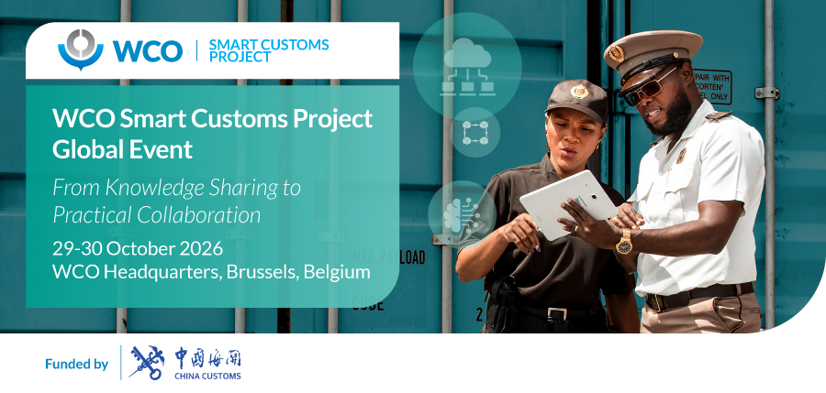

Agenda

Day 1: Thursday, 29 October 2026
English, French, Spanish and Arabic interpretation

08:30 | Registration
09:30 – 09:37 | Opening Ceremony  Display SCP video  Master of Ceremony:  Mr. Adrian SWARRES, Deputy Director Enforcement, Facilitation & Technology, Policy and Standards Directorate, WCO  Opening Remarks  Mr. Ricardo TREVIÑO CHAPA, Deputy Secretary General, WCO
09:37 – 10:00 | Keynote address  Ms. Xueyan GUO, Director General, International Cooperation Department General Administration of Customs of the People’s Republic of China (GACC)  Mr. Eduard HAKOBYAN, Chairman, State Revenue Committee of Armenia
10:00 – 10:30 | Session 1:  Launch of the updated WCO Study Report on Disruptive Technologies  Formal launch and presentation of the updated WCO Study Report on Disruptive Technologies, including its evolution, key findings and value for Members  Moderator:  Ms. Gael GROOBY, Director, Policy and Standards Directorate, WCO  Presenters:  Ms. Vyara FILIPOVA, Head, Data & Technology Policy Unit (DTPU), Policy and Standards Directorate, WCO  Mr. Dimitrios POLITOPOULOS, Manager, Smart Customs Project, DTPU, Policy and Standards Directorate, WCO
10:30 – 11:00 | Session 2:  Member contributions to the updated Study Report  Presentations from Members who contributed case studies to the updated Study Report  Moderator:  Ms. Özlem SOYSANLI, Head, Facilitation Policy Unit, Policy and Standards Directorate, WCO  Presenters:  Ms. Jiayi CHAI, Officer, Reform and Development Division, Department of General Operation, GACC  Mr. Naden VENCATACHELLUM, Section Head Customs, Customs Management System / IT, Mauritius Revenue Authority (MRA)  Ms. Oluwaseun Omolara ADEDEJI, Assistant Comptroller, ICT Modernization, Nigeria Customs Service (NCS)
11:00 – 11:30 | Coffee Break, Networking and a group photo
11:30 – 12:00 | Session 3:  Presentation of the SCP’s deliverables included in the AI/ML and Blockchain packages  Introductory presentation by the Secretariat of the detailed reports, readiness self-assessment tools and case studies, followed by a presentation by a WCO accredited Customs expert (ACE) on the implementation of the AI/ML Readiness Self-Assessment Tool  Presenters:  Dr. Hua TONG, Technical Attaché, Smart Customs Project, DTPU, Policy and Standards Directorate, WCO  Mr. Chamroeun SAN, WCO Data Analytics Expert & Chief of the Data and Statistics Office, IT Department General Department of Customs and Excise of Cambodia (GDCE)
12:00 – 12:45 | Session 4:  AI governance and deployment readiness in Customs  Panel with Members and experts on the importance of AI governance in Customs and on the contribution of tools such as the AI/ML Readiness Self-Assessment Tool  Moderator:  Mr. Joel CHOI, Technical Officer, Lead Smart Customs Project, DTPU, Policy and Standards Directorate, WCO  Panellists:  Mr. Chamroeun SAN, WCO Data Analytics Expert & Chief of the Data and Statistics Office, IT Department General Department of Customs and Excise of Cambodia (GDCE)  Mr. Arturo Jeshván ALCÁNTARA VILLANUEVA, Director General, Electronic Customs Data Processing Agencia Nacional de Aduanas de México (ANAM)  Ms. Hilal ÇENGEL, Assistant Trade Expert, Department of Digital Transformation and Analysis Customs Administration, Ministry of Trade, Republic of Türkiye  Mr. Duyen Phuong PHAM, Deputy Director, IT Customs Statistics, General Department of Vietnam Customs
12:45 – 14:30 | Lunch Break
14:30 – 15:10 | Session 5:  Blockchain adoption in Customs  Presentations from Members already implementing Blockchain Projects on practical experiences, opportunities and challenges  Moderator:  Dr. Hua TONG, Technical Attaché, Smart Customs Project, DTPU, Policy and Standards Directorate, WCO  Presenters:  Mr. Felipe MENDES MORAES, Coordinator-General for Customs Administration  Federal Revenue Service of Brazil (RFB)  Mr. Kin-kei LI, Assistant Commissioner, Excise and Strategic Support, Hong Kong Customs  Mr. Abdulrahman AWADH, Head of Application Development, Abu Dhabi Customs, United Arab Emirates
15:10 – 15:50 | Session 6:  WCO initiatives under Focus Area 1, WCO Strategic Plan 2025-2028  The session will present relevant WCO initiatives under Focus Area 1 of the WCO Strategic Plan 2025-2028, highlighting areas of complementarity, synergies and their contribution to the Organization’s broader work on Technology and Innovation.  Moderator:  Ms. Gordana VIDANOVIĆ, Head, Facilitation Implementation Unit, Implementation and Capacity Development Directorate (ICDD), WCO  Presenters:  Mr. Hyunsang JO, BACUDA Project, Project Manager, Facilitation Implementation Unit, ICDD, WCO  Ms. Maria ORTIZ BOLIVAR, Programme Manager, SECO-WCO Global Trade Facilitation Programme (GTFP), Facilitation Implementation Unit, ICDD, WCO  Mr. Juan Diego CHAVARRÍA VALVERDE, Technical Officer, DTPU, Policy and Standards Directorate, WCO
15:50 – 16:10 | Coffee Break and Networking
16:10 – 17:00 | Session 7:  International cooperation and technology deployment in Customs  Panel with Members, Intergovernmental Organizations (IGOs) and WCO Regional Entities on meaningful technology-based partnerships and cooperation relevant to Customs objectives  Moderator:  Ms. Gael GROOBY, Director, Policy and Standards Directorate, WCO  Panellists:  Mr. Philippe DUPONTEIL, Director for Customs Tariffs and Digital Delivery of Customs and Taxation Policies, Directorate General for Taxation and Customs Union (DG TAXUD), European Commission, EU  Ms. Raghad AL-TALLI, Trade Facilitation Advisor, International Trade Center (ITC)  Mr. Antonio LOPARCO, Director, Regional Office for Capacity Building for the WCO Europe Region (ROCB Europe)  Mr. Joppy Teja SENTANA, Associate Expert Lecturer, Financial Education and Training Agency (FETA) Indonesia, Regional Training Centre (RTC) for the Asia Pacific Region
17:00 - 18:00 | Session 8:  Member experiences in adopting disruptive technologies  Broader exchange with Members on the adoption of disruptive technologies in Customs  Moderator:  Ms. Sigfríður GUNNLAUGSDOTTIR, Deputy Director, Capacity Delivery Sub-Directorate, ICDD, WCO  Panellists:  Mr. Abas JAFAROV, .NET Developer, State Customs Committee of Azerbaijan  Mr. Adékoulé Josué BABALOLA, Head of the Strategic, Economic, and Statistical Studies Division, Directorate General of Benin Customs  Mr. Virgilio Martin CACHAY MONTALVAN, Project Specialist, Office of Institutional Programs and Projects Integration Superintendencia Nacional de Aduanas y de Administración Tributaria (SUNAT), Peru  Mr. Hassan ALSHEHRI, IT Applications Expert, Customs Applications  Zakat, Tax and Customs Authority (ZATCA), Saudi Arabia  Mr. Mathews KALIKITI, Assistant Commissioner, Business Processes and Projects, Customs Services, Zambia Revenue Authority (ZRA)
18:00 – 19:30 | Welcome Reception  Reception for in-person participants

Day 2: Friday, 30 October 2026
English, French, Spanish and Arabic interpretation

 | 09:30 – 09:45 | Opening of Day 2  Recap of Day 1 and introduction to Day 2 by the MC  Master of Ceremony:  Mr. Adrian SWARRES, Deputy Director Enforcement, Facilitation & Technology, Policy and Standards Directorate, WCO
 | 09:45 – 10:15 | Session 9:  International perspectives on AI governance  Presentations by selected IOs / IGOs on their work on AI governance and related frameworks  Moderator:  Mr. Hans PIETERS, Chief Operating Officer (COO), WCO  Presenters:  Mr. Erik WILLEMS, ASYCUDA Programme Management Officer, UN Trade and Development (UNCTAD)  Mr. Christian PIAGET, Head Cargo Border Management & Claims, Operations, Safety and Security – Cargo, International Air Transport Association (IATA)  Dr. Talkmore CHIDEDE, Senior Digital Trade Expert, Digital Trade Division African Continental Free Trade Area - AfCFTA Secretariat
10:15 – 11:00 |  | Dialogue Part 1:  Reflections on lessons learned and emerging needs  Consolidation of key messages arising from the event and reflections on Member needs and priorities in this area  Moderator:  Ms. Gugu DLAMINI-ZWANE, Head, Needs Assessment & Strategic Support Unit, ICDD, WCO
 | 11:00 – 11:30 | Coffee Break and Networking
 | 11:30 – 12:00 | Dialogue Part 2:  Reflections on lessons learned and emerging needs  Consolidation of key messages arising from the event and reflections on Member needs and priorities in this area  Moderator:  Ms. Vyara FILIPOVA, Head, Data & Technology Policy Unit (DTPU), Policy and Standards Directorate, WCO
 | 12:00 – 12:15 | Closing Remarks  Mr. Ian SAUNDERS, Secretary General, World Customs Organization, WCO

